This program aims to simulate **two-dimensional electrophoresis** predict the position of a peptide in the gel given the sequence of the peptide. Two-dimensional electrophoresis is a combination of isoelectric focusing and SDS electrophoresis sequentially. **Isoelectric focusing** separates proteins according to their isoelectric point, or pI, the pH value where the net charge. A linear pH gradient is established across the electric field. Each protein migrates until it reaches the pH that matches its pI.

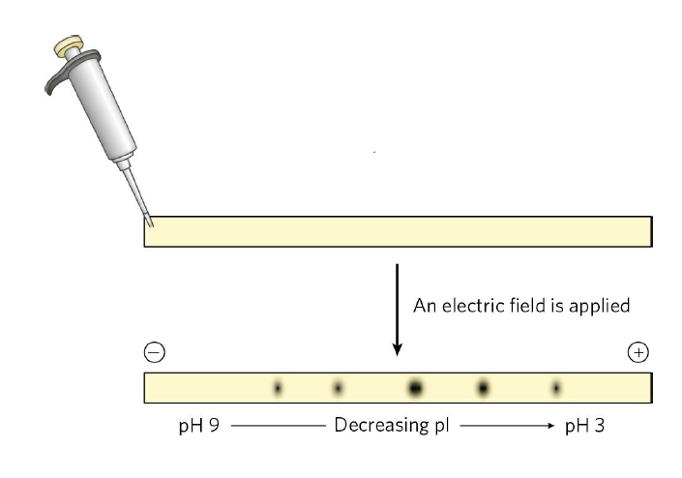

**SDS electrophoresis separates** proteins according to their molecular weights. The relative migration of the protein decreases linearly with the logarithm of Mw.

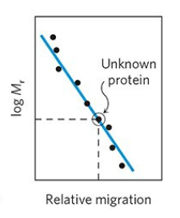

Therefore, to predict the position of a peptide, we need to calculate its pI and Mw.

An additional function that visualize the amino acid composition of a peptide is added.